**User guide**

**Beko Kettle**

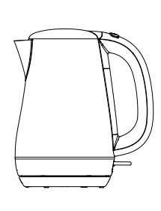

**Beko Kettle User Guide**

Contents

**Safety Instructions** 2

Electrical Safety 2

Usage Safety 2

Hot Surface Safety 2

**Features and Functions** 3

Water Level Indicator 3

Boiling and Auto Shut-Off 3

Removable Filter 3

**Operation** 4

Filling the Kettle 4

Heating the Water 4

Pouring the Water 4

Cautions 4

Warnings 4

**Cleaning and Maintenance** 5

Descaling 5

Cleaning 5

**Troubleshooting** 6

Kettle Won't Turn On 6

Kettle Won't Boil 6

**Warranty** 7

# **Safety Instructions**

Before using the kettle, read and follow these safety instructions

## Electrical Safety

* The kettle should be plugged into a properly grounded electrical socket
* Do not touch the kettle or plug with wet hands or when standing in water
* Do not attempt to modify the plug or cord in any way

## Usage Safety

* Do not overfill the kettle beyond the maximum fill line
* Do not leave the kettle unattended while it is heating
* Do not use the kettle if it is damaged or if the cord is frayed

## Hot Surface Safety

* Do not touch the kettle while it is heating or immediately after use as it can be hot and cause burns
* Place the kettle on a flat, stable surface to avoid tipping or spilling

# **Features and Functions**

## Water Level Indicator

* The water level indicator shows how much water is in the kettle
* The indicator is located on the side of the kettle and marked with minimum and maximum fill lines

## Boiling and Auto Shut-Off

* The kettle will automatically shut off when the water has boiled
* The kettle will also shut off if it is removed from the base while heating

## Removable Filter

* The kettle includes a removable filter to reduce limescale build-up and improve water quality
* The filter is located inside the spout and can be easily removed and cleaned

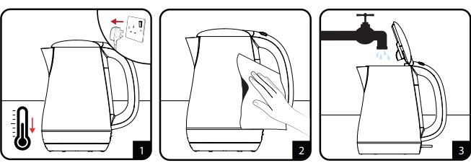

Figure 1

# **Operation**

## Filling the Kettle

* Open the lid of kettle
* Fill the kettle with desired amount of water, making sure not to exceed maximum fill line
* Close the lid tightly

## Heating the Water

* Place the kettle on base
* Plug the kettle into a properly grounded electrical socket
* Press power switch to start heating the water
* Kettle will automatically shut off when the water has boiled

## Pouring the Water

* Remove the kettle from base
* Open the lid of kettle
* Carefully pour the hot water into a cup or other container

## Cautions

* Do not touch the kettle while it is heating or immediately after use as it can be hot and cause burns
* Do not overfill the kettle beyond maximum fill line
* Do not use the kettle if it is damaged or if the cord is frayed
* Do not immerse the kettle or base in water
* Use a soft, damp cloth to wipe the exterior of the kettle for cleaning

## Warnings

* Do not touch the kettle or plug with wet hands or when standing in water
* Do not leave the kettle unattended while it is heating
* Keep the kettle out of reach of children and pets
* If the kettle is dropped or damaged, unplug it and do not use it until it has been inspected by a qualified technician

# **Cleaning and Maintenance**

## Descaling

* Over time, limescale build-up may occur inside the kettle
* To remove limescale, fill the kettle with equal parts water and vinegar and let it sit for 1-2 hours before rinsing thoroughly

## Cleaning

* Before cleaning, unplug the kettle and let it cool down
* Use a soft, damp cloth to wipe the exterior of the kettle
* Do not immerse the kettle or base in water

# **Troubleshooting**

## Kettle Won't Turn On

* Check if the kettle is properly plugged into the electrical socket
* Check if the electrical socket is working
* Check if the kettle is properly seated on the base

## Kettle Won't Boil

* Check if there is enough water in the kettle
* Check if the kettle is properly seated on the base
* Check if the kettle is plugged in and turned on

# **Warranty**

The Beko kettle comes with a limited warranty. Please refer to the warranty information included with the kettle for more details

*Note: This user guide is intended to provide basic instructions and information for using the Beko kettle. For more detailed information, please refer to the instruction manual included with the kettle.*